 | Collinsvale Primary School  508 Collinsvale Road, Collinsvale 7012  Phone: (03) 6239 0176  Email: collinsvale.primary@education.tas.gov.au | 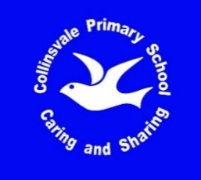

Collinsvale Primary School Uniform List

CODE | DESCRIPTION | SIZE | PRICE
5220TP | Polo Shirt - short sleeve  (Royal Blue & White with logo) | 4, 6, 8, 10, 12, 14, 16 | $25.00
5880CZ | Polar Fleece Half Zip Jumper  (Royal Blue with logo) | 4, 6, 8, 10, 12, 14, 16 | $26.00
 | School Dress | 4, 6, 8, 10, 12, 14, 16 | $60.00
7WUZPN | Microfiber Straight Leg Track Pant  (Navy Blue with logo and zips in legs) | 4, 6, 8, 10, 12,14 | $34.00
TS7NWSSN | Shorts – Navy Blue - with logo | 4, 6, 8, 10, 12, 14 | $22.00
 | Navy Blue Puffer Jacket - with logo | 6 - 8  8 - 10  10 - 12  12 - 14 | $80.00
BH4900 | Bucket Hat – Royal Blue  (Brushed cotton) | XS / 53cm  S / 55cm  M / 57cm | $ 6.00
B8100 | Beanie - Polar Fleece - Royal Blue | One Size | $ 6.00
S0300 | Scarf – Polar Fleece – Royal Blue |  | $6.00
4150CG | Gloves – Royal Blue | Children’s – one size | $3.00
B08623 | Junior Backpack – Royal Blue – (waterproof – with logo) |  | $36.00
 | Library Bag – Royal Blue – with logo |  | $13.00
 |  | Updated: 27 June, 2023
CPS Uniform Order Form

Student Name/s: _________________________________ Class: __________

Date of Order: _____________________

DESCRIPTION | SIZE | QTY | UNIT  COST | TOTAL  COST | SUPPLIED  (Office Use Only)
 |  |  | TOTAL | $

Office Use Only:

PAID: Cash / Eftpos (please circle)

